Accela Standard Operating Procedure

# Table of Content

Table of Content 2

Document Version History 3

1. About 4

2. Stakeholders 5

3. Servers 6

4. Database 7

5. Architecture Diagrams 8

5.1 Production Environment 8

5.2 Development Environment 9

6. Standard Maintenance Schedule 10

7. Standard Maintenance Procedures 11

7.1 Database Maintenance Procedures 11

7.2 Server Maintenance Procedures 11

7.3 Application Maintenance Procedures 11

8. Common issues and solutions 16

9. Patch management 17

9.1 Server 17

9.2 Application 17

9.3 Database 17

10. Security Vulnerability Process 18

11. Cross Training Strategy 19

12. Monitoring 20

13. Interfaces 21

14. Backup/Recovery 22

14.1 Servers 22

14.2 Database 22

14.3 Application 22

# Document Version History

|  |  |  |
| --- | --- | --- |
| **Date** | **Author** | **Change** |
| 6/22/2017 | David Robinson/Tai Cochran | Original Document Creation |
| 1/18/2018 | Joseph Bullock | Revised for Accela SOP |
|  |  |  |
|  |  |  |
|  |  |  |

# About

Accela is the System of Record for Atlanta’s Building and Trade Permits, Watershed Site Development permits, Professional Trade Licenses, Building and Trade inspections and enforcement, Atlanta Police Code Enforcement cases, Fire Department inspections, Zoning and Development cases, Housing cases, and Finance liens.

# Stakeholders

|  |  |  |
| --- | --- | --- |
| Application Support | Technical Support:  Joseph Bullock (All excluding Fire)  Deangelo Rowland (Fire) | Functional Support:  Christopher Colbert (OOB)  Joy Hall (OOB)  Rose Connolly (Watershed)  Daphne Talley (Police)  Paul Thomas (GIS) |
| Security Vulnerability Remediation |  |  |
| Database Support | DBA Team (Olusegun Odukoya) |  |
| Server Support | Accela (Cloud-Hosted) |  |
| Vendor Support Information | Accela (925) 659-3200 | (888) 722-2352  Account Executive:  Jeffrey Reese (mob) 941-628-1495 | |
| Users | Office of Buildings, Office of Zoning & Development, Atlanta Police Dept. Code Enforcement Division, ATL311, Office of Housing & Community Development, ATL GIS, Finance, General Public via Citizen Access Gateway (Accela) and Integrated Voice Response (IVR) from Selectron vendor. | |

# Servers

Do not document this here. This should be maintained in [APMS](http://coanet/apms/summary.aspx?ID=1131).

# Database

Do not document this here. This should be maintained in [APMS](http://coanet/apms/summary.aspx?ID=1131).

# Architecture Diagrams

## Production Environment

<https://av3.accela.com>

[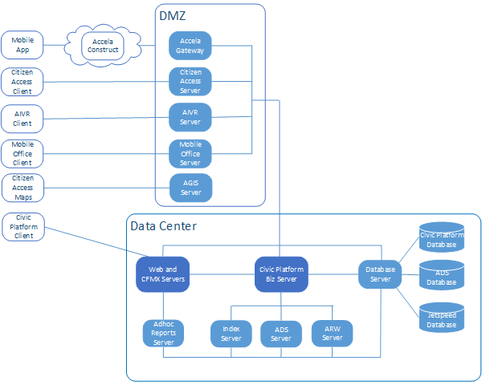](http://citynet/AIM/KronosIIIteamsite/Shared%20Documents/AIM/Technical%20Documents/Kronos%20Prod%208%20Environment_update05112017_v3.pdf)

## Development Environment

<https://avsupp3.accela.com>

<https://avtest3.accela.com>



# Standard Maintenance Schedule

|  |  |  |  |  |  |  |
| --- | --- | --- | --- | --- | --- | --- |
| Application Maintenance | Owner | Daily | Weekly | Monthly | Quarterly | Yearly |
| **Accela On-Premise Test Database Refresh:** | Database Team |  |  |  | X |  |

# Standard Maintenance Procedures

## Database Maintenance Procedures

Production database is maintained by Accela

## Server Maintenance Procedures

Servers are maintained by Accela

## Application Maintenance Procedures

### Accela On-Premise Test Database Refresh

From Accela server (DIT-ACELADB-NEW) logged into their ftp site :

ftp.accela.com

username - atlanta.ga.. Password in DIT-DBA password file

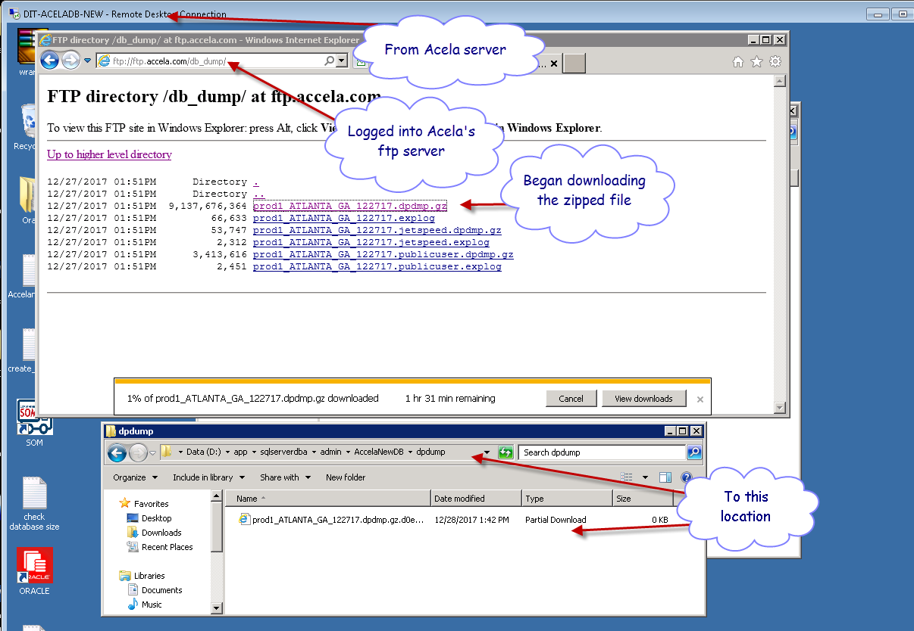

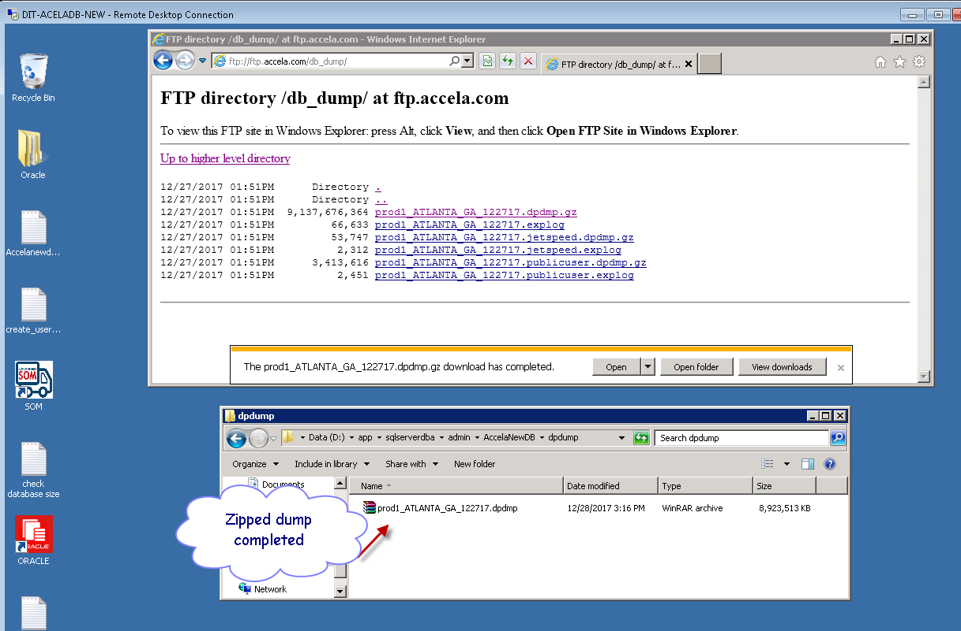

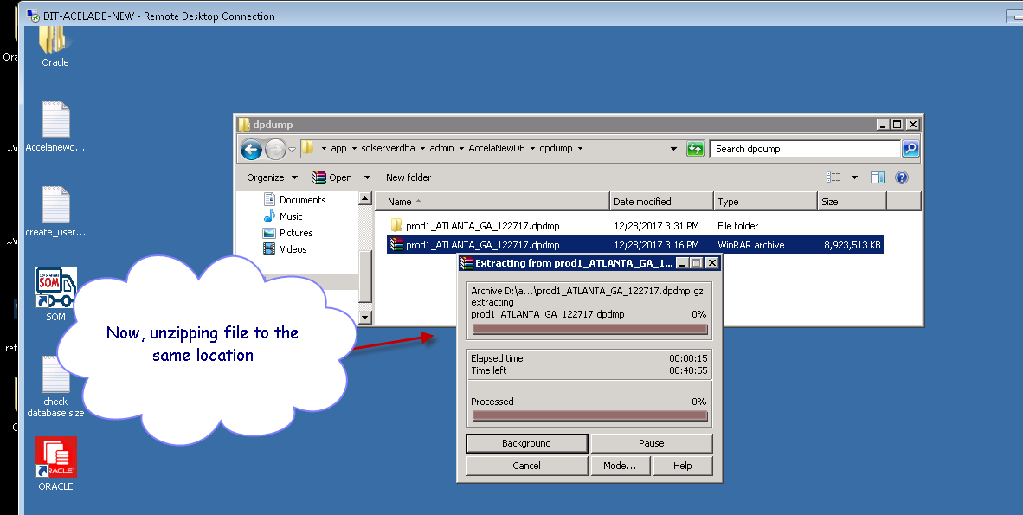

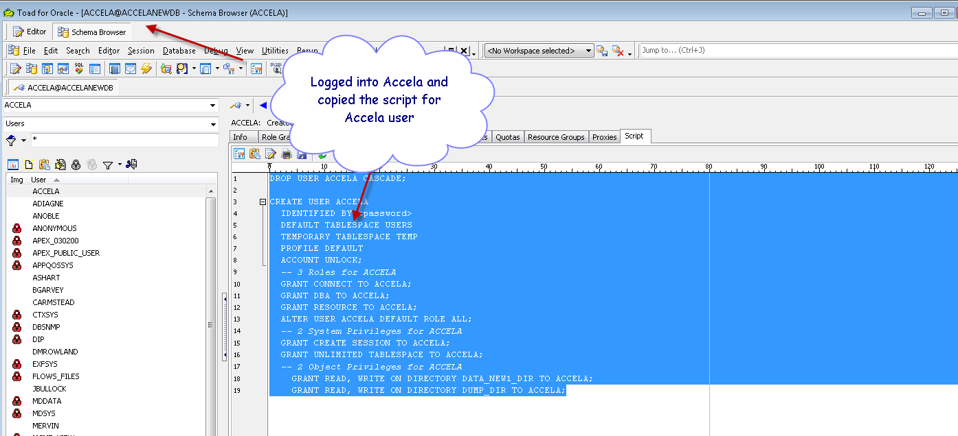

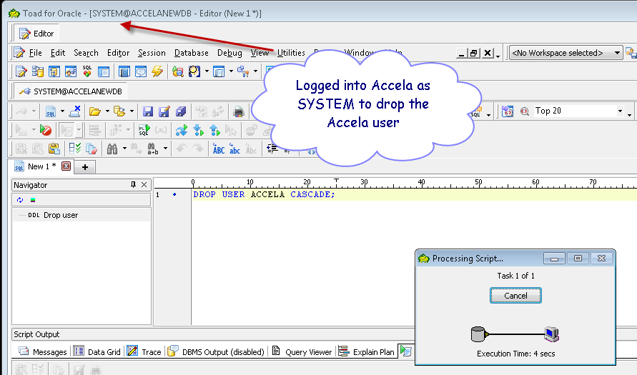

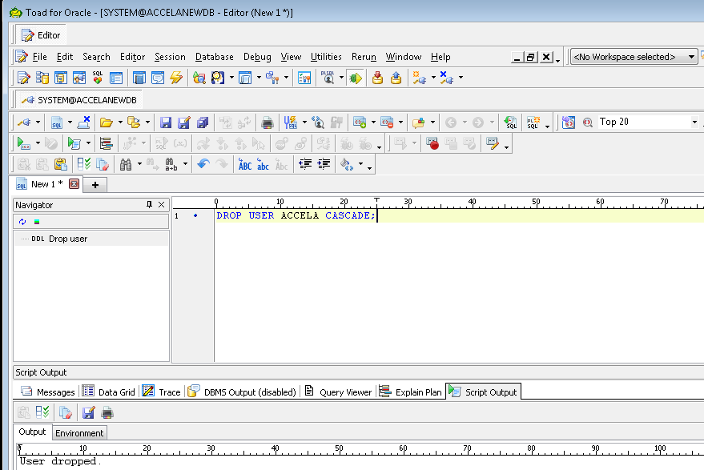

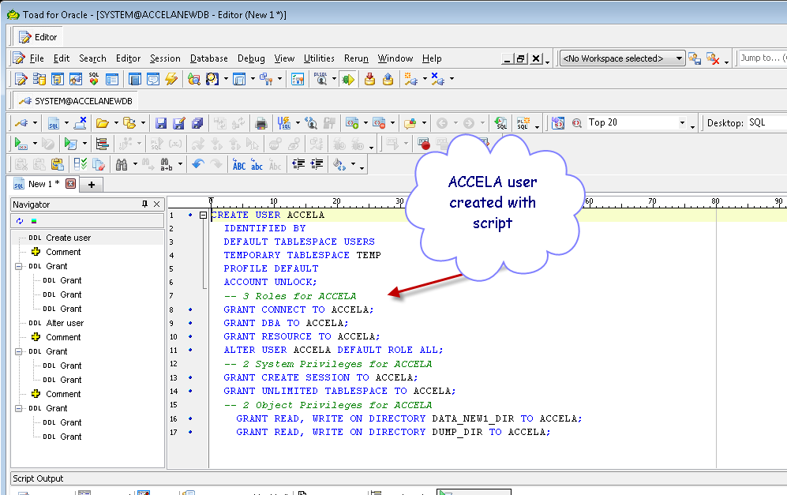

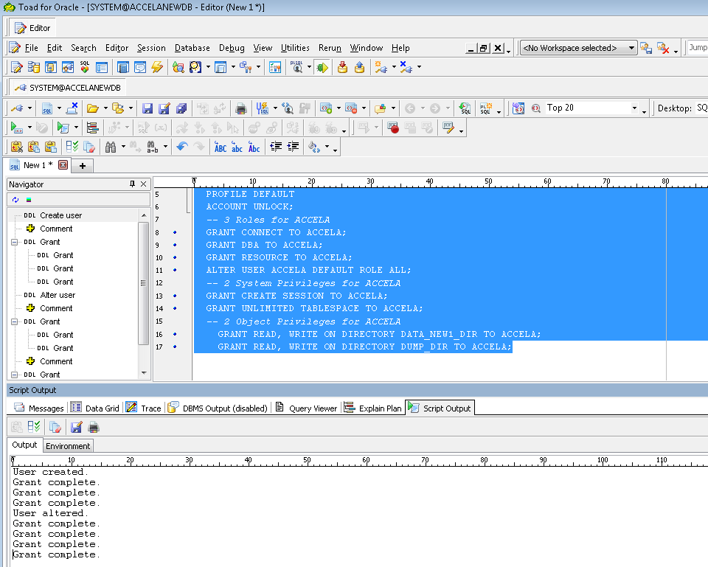

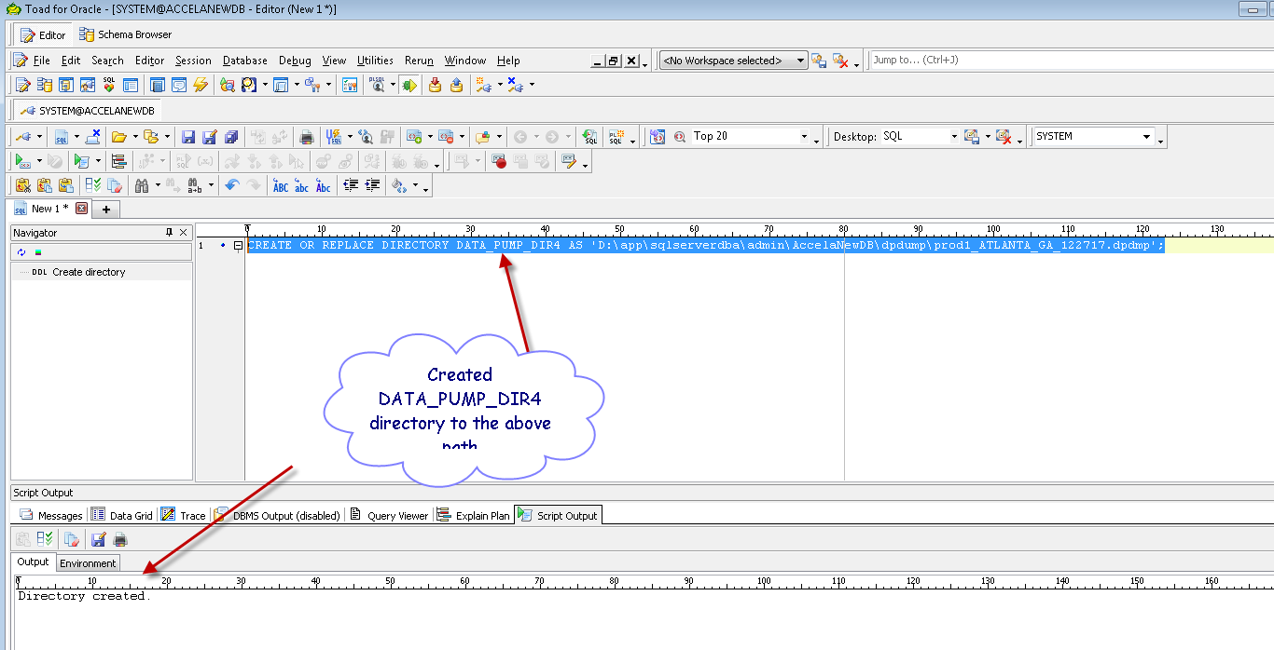

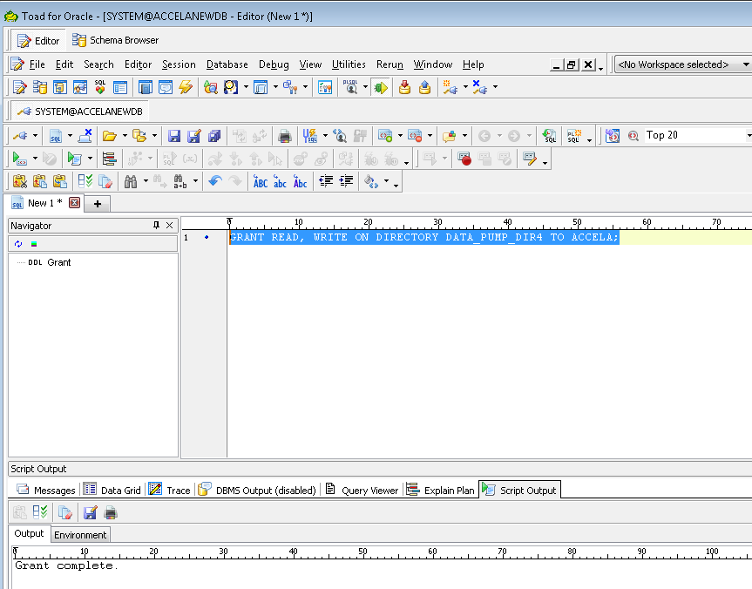

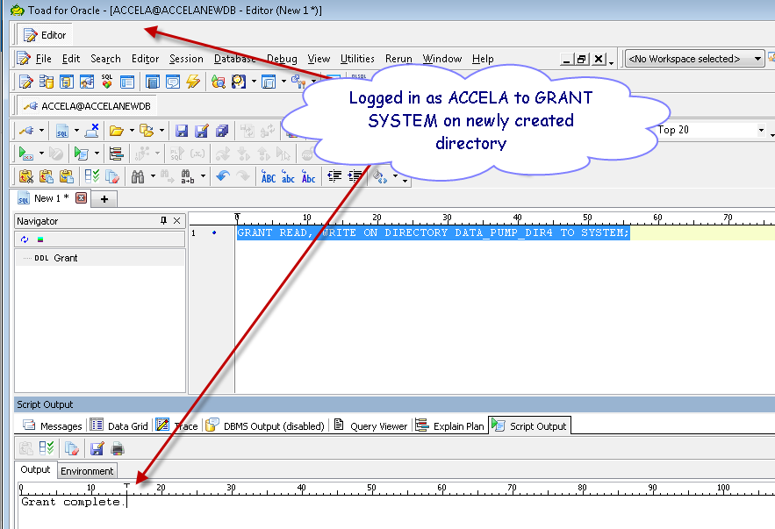

Using import script :

impdp system/xxxxxxxxxx directory=DATA_PUMP_DIR5 dumpfile=prod1_ATLANTA_GA_122717.dpdmp TABLE_EXISTS_ACTION=REPLACE logfile=prod1_ATLANTA_GA_122817.log full=N remap_schema=accela:accela

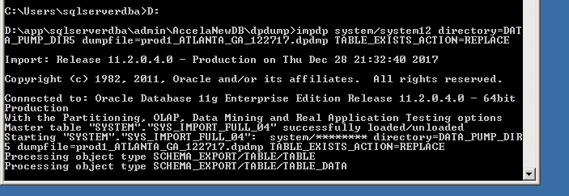

After import completed, logged into TOAS as ACCELA user via TOAD and ran :

EXEC DBMS_UTILITY.compile_schema(schema => 'accela');

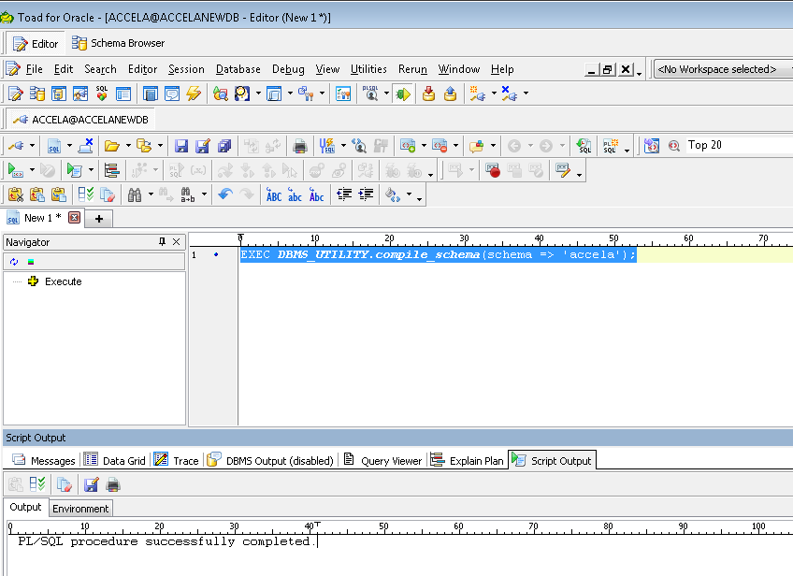

And ran the below script to recompile invalid objects :

select

'ALTER ' || OBJECT_TYPE || ' ' ||

OWNER || '.' || OBJECT_NAME || ' COMPILE;'

from

dba_objects

where

status = 'INVALID'

and

object_type in ('PACKAGE','FUNCTION','PROCEDURE')

;

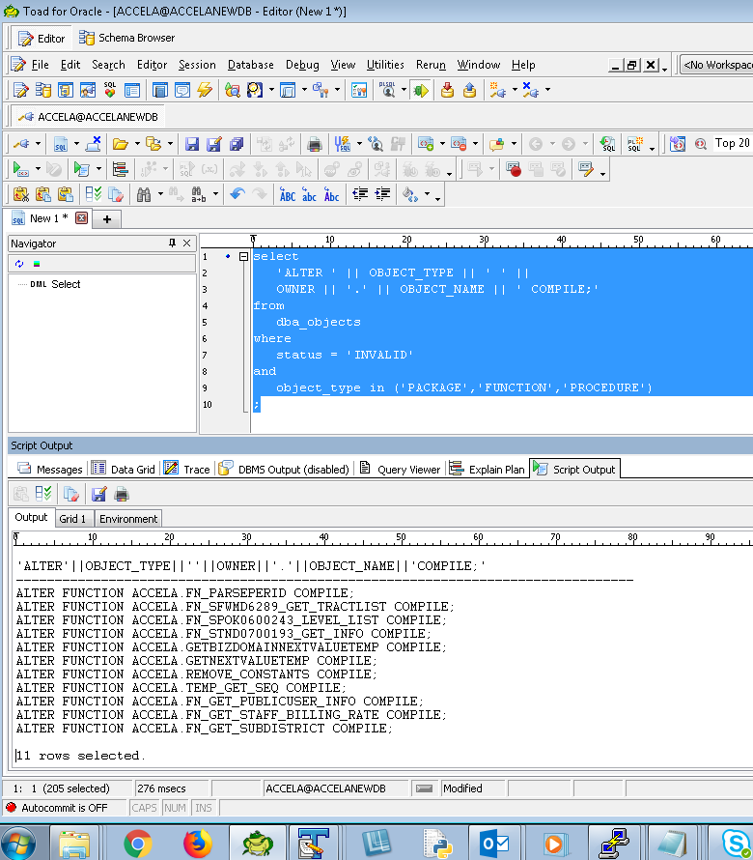

# Common issues and solutions

[Accela Success Community](https://accela.force.com/success)

**Training Videos for Managers**

Need Accela Success Community login for access to training materials. No materials have been uploaded to Citynet.

**Training Videos for Employees**

Need Accela Success Community login for access to training materials. No materials have been uploaded to Citynet.

# Patch management

## Server

Patching of servers is maintained by Accela.

## Application

### Patching Frequency and strategy

If an update is scheduled, members of the Accela Success Community are notified and, in response, a Change Control Board ticket is submitted for approval. Frequency is as-needed, as Accela sees fit.

## Database

Patching of databases is maintained by Accela.

# Security Vulnerability Process

No security vulnerability process has been outlined yet.

# Cross Training Strategy

Weekly meetings held by Joseph Bullock to stake-holders for each office, where he describes the processes and tools he uses to make configuration changes as-needed.

# Monitoring

No monitoring procedure has been implemented.

# Interfaces

[Accela Interfaces](http://coanet/apms/summary.aspx?ID=1120) (APMS)

# Backup/Recovery

## Servers

## Database

TNS: ACCELANEWDB (Test Database Export – Updated Quarterly)

## Application